OMT Test: High Order/Low OMT Count Test

This test involves loading routing 15000 orders to two OMT GUIs followed by log-out and log-in on the OMT. The purpose of the test is to verify the ability of OHS and OMT to handle transfer of large number of orders to OMT upon login.

Test Setup

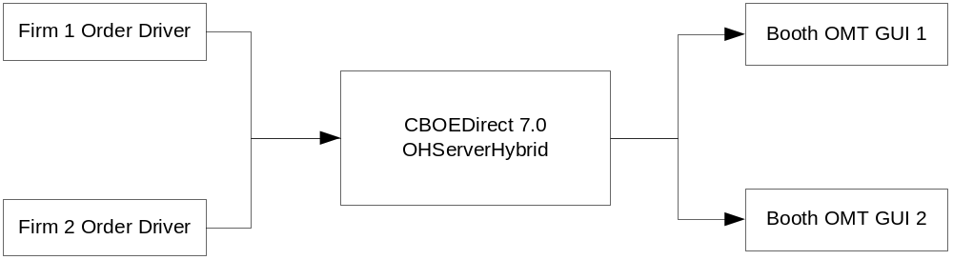

Figure 1: High number of orders at OMT

Procedure
For the purpose of this test procedure, firm 551 and 671 are used and their respective Booth OMT users PRF51 and PRF71 are used.
- Define Booth Default Destination routing property for firm 551 to be PRF51.
- Define Booth Default Destination routing property for firm 671 to be PRF71.
- Define Firm Volume Limit Simple Order routing property for both firms 551 and 671. Set the Firm Volume Limit Simple Order value to 10.
- Prepare two order drivers with following parameters. One order driver is for firm 551 and the second order driver is for firm 671. With duration and order rate set as below, each OMT should have approximately 15000 orders.
  - Customer orders with NONE contingency
  - No Cancel and No Fills
  - 25 orders/sec
  - Duration: 10 minutes or until both OMTs have at least 15000 orders.
- Start OMT GUIs and log-in user PRF51 and PRF71. Launch the OMT Message Window once logged-in.
- Start the order drivers.
- Confirm that the two OMT GUIs are receiving orders in the OMT Message Window
- Stop the order driver when both OMTs have at least 15000 orders.
- Log-out PRF51
- Re-login PRF51 and launch OMT Message Window. Confirm that all orders originally at PRF51 are re-displayed on PRF51 OMT Message Window upon re-login.
- Repeat steps 9 and 10 for PRF71.
- Repeat steps 9 and 10 for both PRF51 and PRF71 simultaneously.

After CAS Perf1 rollout:

This test involves route order to OMTs in different CAS. Follow by Helpdesk OMT user query orders. The purpose of this test is to verify the Helpdesk OMT user login to CAS2 will able to query orders from OMT user in CAS1

Test Procedure:

- Log in Helpdesk OMT with different CAS than OMT1 and OMT 2 (e.g. if user OMT1 and OMT 2 login to CAS1, Helpdesk OMT should login CAS2).
- From Helpdesk OMT query orders from OMT1, OMT2.
- Confirm that the Help-Desk query result shows the correct number of orders for each OMT.

